Objectives:

* Using the while and for loops

**There are 5 challenge exercises, each worth 20%**

Please submit this document for grading when completed… Please work in groups.

This lab class exercise is based on Chapter 4 Loops.

**CONCEPT**: A repetition structure causes a statement or set of statements to be executed repeatedly.

**Project #1** (here is a program that will ask to enter the sales with commission 3x, without a loop)

**CONCEPT**: A condition-controlled loop causes a statement or set of statements to repeat if a condition is true. In Python, you use the while statement to write a condition-controlled loop.

**Project #2** (Here is the same program but using the while loop)

**Project #3** (using the while loop for temp)

**Challenge Exercise #1:** Create a program with a **while** loop, that will ask the user to enter 4 sets of temps under 102.5 and then get the sum and average of the four temps when the user enters a temp over 102.5.

Data set test: enter 60, 70, 80, and 90.

**#1 Print screen the output with the code below here.**

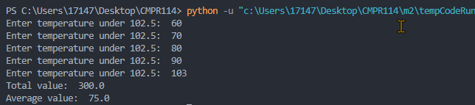

Code:

max_temp = 102.5

checkval = True

loopno = 0

totalval = 0

while checkval == True:

tempval = float(input("Enter temperature under 102.5: "))

if tempval < max_temp:

totalval = totalval+tempval

loopno = loopno + 1

else:

checkval = False

avgval = totalval / loopno

print("Total value: ", str(totalval))

print("Average value: ", avgval)

**Project #4** (example of an infinite loop), a loop that never stops.

**Challenge Exercise #2:** Create a program with a **while** loop, that will ask the user to enter the sales with commission four times, and on the 4th, time will sum the sales and commission.

**#2 Print screen the output with the code below here.**

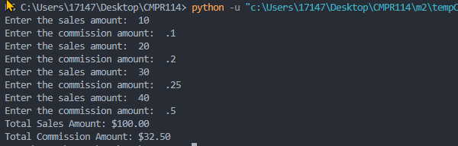

Code:

checkval = 0

totalsales = 0.0

totalcomm = 0.0

while checkval < 4:

sales = float(input("Enter the sales amount: "))

comm_rate = float(input("Enter the commission amount: "))

commission = sales * comm_rate

totalsales = totalsales + sales

totalcomm = totalcomm + commission

checkval = checkval + 1

print("Total Sales Amount: $", format(totalsales, ",.2f"), sep="")

print("Total Commission Amount: $", format(totalcomm, ",.2f"), sep="")

**CONCEPT**: A count-controlled loop iterates a specific number of times. In Python, you use the for a statement to write a count-controlled loop.

**Project #5** (using the for loop to print 1-5)

**Challenge Exercise #3:** continuing with project #5, print odd and even numbers to a maximum of 10.

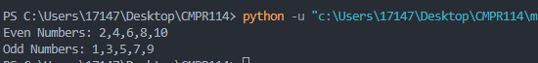

Code:

evenstr = ""

oddstr = ""

for num in [1,2,3,4,5,6,7,8,9,10]:

numtype = num % 2

if numtype == 0:

evenstr = evenstr + str(num) + ","

else:

oddstr = oddstr + str(num) + ","

print("Even Numbers: " + evenstr[:-1])

print("Odd Numbers: " + oddstr[:-1])

**Project #6 (**Looping strings)

**#3 Print screen the outputs with the code below here.**

**Challenge Exercise #4:** continuing from project #6, delete the names in the array and add your first and last name using a parallel for loops (use two for loops). The first loop will loop through your last name, and the second loop will print your first name. See the example below.

**#4 Print screen the outputs with the code below here.**



Code:

for lname in ["Le"]:

for fname in ["John"]:

print(f"Your full name is {lname} {fname}")

**Project #7 (**Looping through a range of #’s)

**Challenge Exercise #5:** Continuing with project #7, display the hello world message 10x.

**#5 Print screen the outputs with the code below here.**

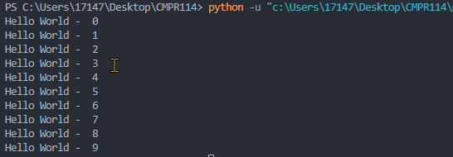

Code:

for x in range(10):

    print("Hello World - ", str(x))

**Project #8 (**Looping and getting the square root of a number)

**Submit this document to the Module 2 class exercise.**